Draft
Hamden Traffic Calming Policy

8/15/11

Traffic Calming
“Traffic calming is the combination of mainly physical measures that reduce the negative effects of motor vehicle use, alter driver behavior, and improve conditions for non-motorized street users.”
-The Institute of Transportation Engineers (ITE)
By design, traffic calming is a self-enforcing traffic management approach that forces motorists to
alter their speed or direction of travel. The purpose of traffic calming is to improve safety, especially for pedestrians and bicyclists, and to improve the environment or “livability” of streets for residents and visitors. Enhanced safety is one of the most fundamental benefits of traffic calming. By decreasing volume and/or reducing speed the number and severity of accidents is greatly diminished.

The objectives of traffic calming include:
- Slow vehicular travel speeds
- Increase safety for non-motorized street users
- Reduce the frequency and severity of collisions
• Increase access for all modes
- Reduce the need for police enforcement
- Enhance the street environment
- Reduce cut-through motor vehicle travel patterns

Traffic calming techniques may include education, enforcement, or engineering – “the three E’s” – to shift traffic patterns and/or reduce speeds. Most traffic calming measures focus on engineering changes to alter driver behavior. Traffic calming techniques may include physical changes such as roadway narrowing, speed humps, raised intersections, traffic circles, pavement markings, signage, and others. Education and enforcement efforts should be considered prior to engineering alternatives and as a complement to engineering efforts.

Tools

Traffic calming measures can generally be separated into three groups based on the goal they are trying to achieve: speed control, volume control, and safety enhancement. These three categories are not as distinct as they may seem as speed reduction measures may divert traffic to other streets and efforts to control cut-through traffic may also decrease the speeds of the traffic using the road. Safety enhancement measures are not implemented for the sole purpose of calming traffic rather they are installed to address a safety concern. However, certain safety enhancements have the additional benefit of raising driver awareness and slowing traffic.
Effective traffic calming strategies often include using more than one of the tools. Traffic calming should be designed with a systematic approach with appropriate and frequent enough spacing of measures and consideration for secondary effects of the installations. For full guidance on traffic calming features and applications, refer to SCRCOG’s Traffic Calming Resource Guide.

Speed Control Measures
- Speed Hump | - Modern Roundabout | - Landscaping
- Speed Table | - Traffic Circle | - Gateway
- Raised Crosswalk | - Narrowed Lane | - StationaryRadar Sign/Speed
- Raised Intersection | - Neckdown/Bulb Out/Curb Extension | - Display Board
- Rumble Strip | - Chicane | - Pavement Marking
- Textured and Colored Pavement | - Traffic Island/Median | - Signage
- On-Street Parking | - Reduced Corner Radii | - Edge Treatment

Volume Control Measures
- Roadway Closure
- Diverter
- Turn Restriction
- One-way Street/ Circulation Change
Safety Enhancements
- In Pavement Lighting
- Bike Lane
There is not a single tool to solve all traffic issues and one tool that may work well in one area for a particular issue may not be effective in another situation. Key to successful traffic calming is community acceptance and municipal support/maintenance. Not every tool may be appropriate or acceptable for each street or neighborhood. Again, certain measures may or may not realize their full advantage or drawbacks depending on site specific conditions and circumstances.
The Process

Any successful traffic calming study and implementation process involves public participation and significant coordination to develop reasonable solutions that address neighborhood concerns regarding traffic safety and flow. The following describes a general but systematic approach for a traffic calming study process. Community involvement and approval is one of the most important aspects of a traffic calming study process and the ultimate success and acceptance of the project.

Step 1: Request from an individual or neighborhood: Residents may submit written requests to the Town identifying their needs and request for a traffic calming review. Hamden may require that the request be a petition which would require a minimum number of signatures.

Step 2: Initial Determination of Eligibility: The Traffic Department will assess the application to ensure that the requested location is eligible for further consideration. This initial eligibility is determined by the roadway functional classification and land use. Traffic calming measures will be considered on the following roadway types:
- Local residential streets (two lane and not including cul-de-sacs)
- Collector streets with predominately residential uses (two lane)
- Arterial roads – within downtown or school districts and /or with posted speeds of 40 mph or less (typically two lane)

Step 3: Traffic Data Inventory- Data will be assessed or collected to determine whether the project meets the following criteria:

1. Traffic Speed Profile –In order to qualify for further review, the critical speed (or 85th percentile speed) shall exceed the posted speed limit by a minimum of 5 MPH. Special circumstances such as an area of high pedestrian activity may warrant a threshold of 1MPH in excess of the posted speed limit.

2. Accident History – Accident data that shows a high incident of accidents that appear to be related to excessive speeds or unsafe motorist behavior.

3. Traffic Volume Counts –The traffic volume of the study boundary must exceed the expected trip generation volume by at least 50%.

To qualify the street segment for further review and the ranking process for traffic calming/management strategies deployment, one of the above stated criteria should be met.

Step 4: Traffic Department consults with other Municipal Departments - The Traffic Department would meet with other municipal officials including but not limited to: Police, Fire and Public Works. These various departments should be updated on the status of the Traffic Calming request and given an opportunity to weigh in on the feasibility of the project.

Step 5: Traffic Department notifies residents within the project area of the Community Meeting – The town mails meeting notifications to all residents within the project area and to other residents who live within 1,000 feet or one block length from the proposed traffic calming street segment(s), whichever is greater.

Step 6: Conduct Community Meeting –Residents will be given the opportunity to present their concerns and discuss traffic calming alternatives. Once residents agree on the traffic issues and on the likely traffic calming features for the study area, residents will be asked to vote to move the process forward. If approximately 75% or more of residents vote in favor of pursuing traffic calming, the process is allowed to move forward.

Step 7: Collect and Analyze Traffic Data - The Traffic Department should follow up the initial assessment with additional data collection and analysis. The data collected can also be used to document the “before traffic calming” condition. Traffic volume and speeds are generally the basis of a traffic calming study request. Additional data collected includes:
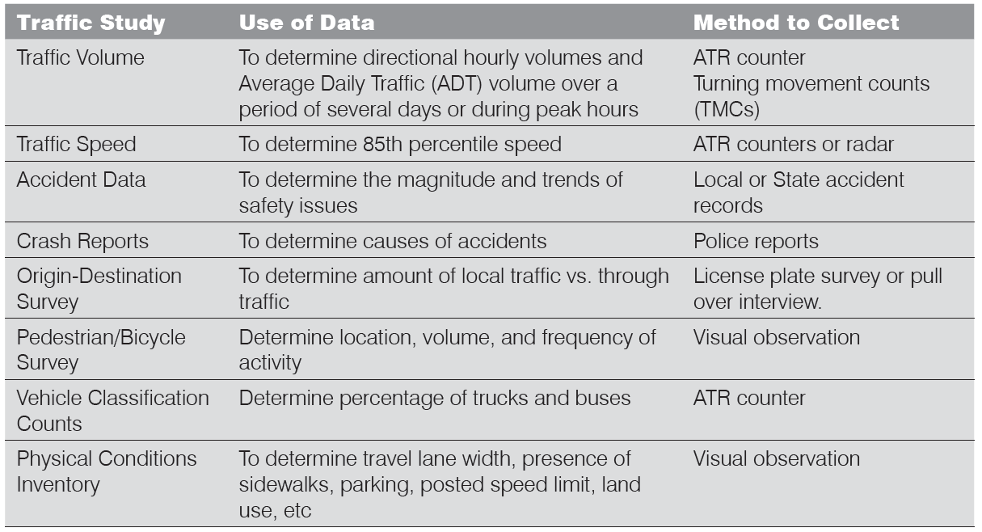

Step 8: Identify Traffic Calming Tools and Strategy – The Traffic Department will identify the appropriate traffic calming solutions for the project area. These solutions will be based upon data collection and analysis as well as feedback received from the community meeting.

Step 9: Meet with key stakeholders - Key stakeholders should be notified of the proposed traffic calming solution. These stakeholders include abutting property owners and municipal officials including but not limited to Public Works, Police, and Fire Departments.

Step 10: Hold Public Hearing – The Traffic Authority holds a public hearing at its regular meeting to receive public comments regarding the proposed traffic calming strategy.

Step 11: Traffic Authority’s Recommendation – The Authority can adopt and/or modify the traffic calming strategy and direct staff to proceed. If significant modification of the traffic calming strategy is required, the Traffic Department may be required to meet with key stakeholders again and present again at Public Meeting.

Step 12: Ranking of Project - Each project will be given a score based on the following criteria. A ranking (priority) list will be developed based on the scores. The table below should be used to score the candidate project and compare it to other projects so that a priority list can be developed. Projects with the most total points are ranked highest. The table consists of seven (7) basic criteria as described below:

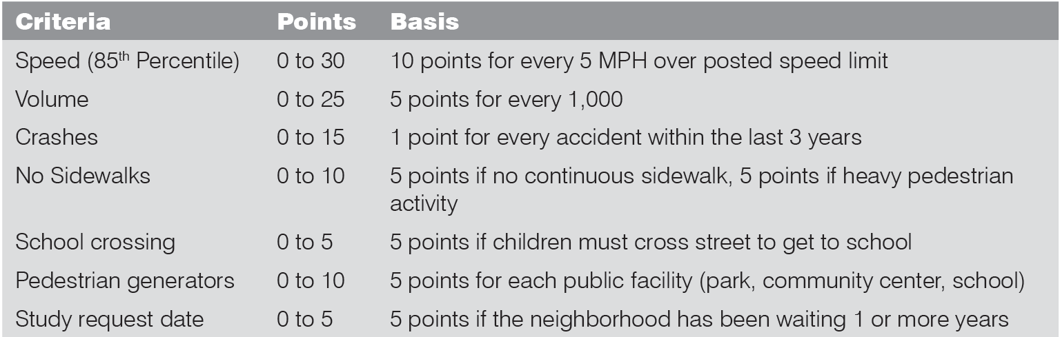

Step 13: Identify and secure Funding – A funding source to construct the traffic calming project will need to be identified. It is possible that some projects might have to wait for funding to become available for construction. Funding could come from the municipality’s capital improvement program, roadway maintenance budget, or from a fund specially created for traffic calming. If a project is elected to be installed first as a temporary measure, funding should be secured to remove the measure at the conclusion of the test period and/or construct the permanent solution.

Step 14: Design and construction – Complex traffic calming schemes may require construction documentation and may go through a bidding process with a contractor performing the construction. Temporary measures or standard solutions such as speed humps or striping may proceed directly to implementation/construction and could potentially be installed by Public Works Staff.

Step 15: Review and Monitoring Reporting – The Traffic Department should monitor the conditions of a traffic calming measure after it is installed. This collection of data will assist in document the effectiveness of the traffic calming measure. If a temporary measure is installed, it should be in place for 6 months before being reviewed and subsequently replaced with a permanent measure or removed. Any permanent installation should also be in place for at least 6 months before data is collected for evaluation. If necessary, modifications could be made to the installed traffic calming measure.

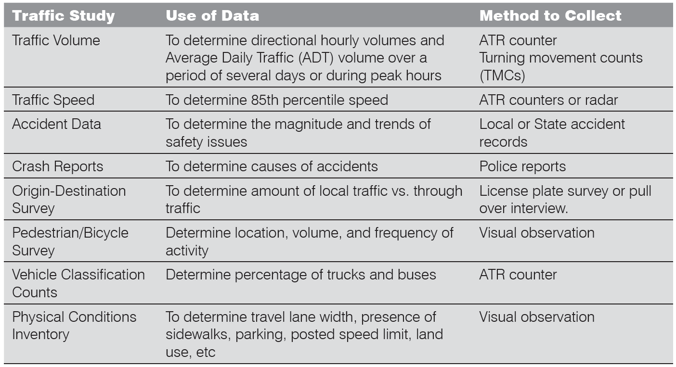
YES
YES
Review & Monitoring
Design & Construction
Secure Funding
Rank and Prioritize Project
Hold Public Hearing
NO
Revise Traffic Calming Strategy
Traffic Authority Approval?
Meet with key stakeholders
Identify Traffic Calming Tools & Strategy
Collect and analyze traffic data
NO
YES
NO
No Traffic Calming Option
75% Buy In?
Qualified
for TC ?
Conduct Community Meeting
Residents are notified of Community Meeting
Consult with municipal departments
Eligible
Not Eligible
No Traffic Calming Option
Initial
Review
Traffic Data Inventory
Traffic Calming Request

